
Ashford Pollinator Pathway News
____________________________
See you next Spring!

With our gardens shutting down for the winter and end-of-year holidays almost upon us, Ashford PP news is taking a break until next Spring. But during the winter we will continue to work behind the scenes encouraging and supporting gardeners and land owners to work with native plants, reduce lawn size, and avoid pesticides. We are already planning town pollinator activities for next year and are coordinating with surrounding towns and organizations on projects that will promote the use of native plants regionally. We are also collecting seeds and growing native plant seedlings over the winter to share with you at events next Summer.
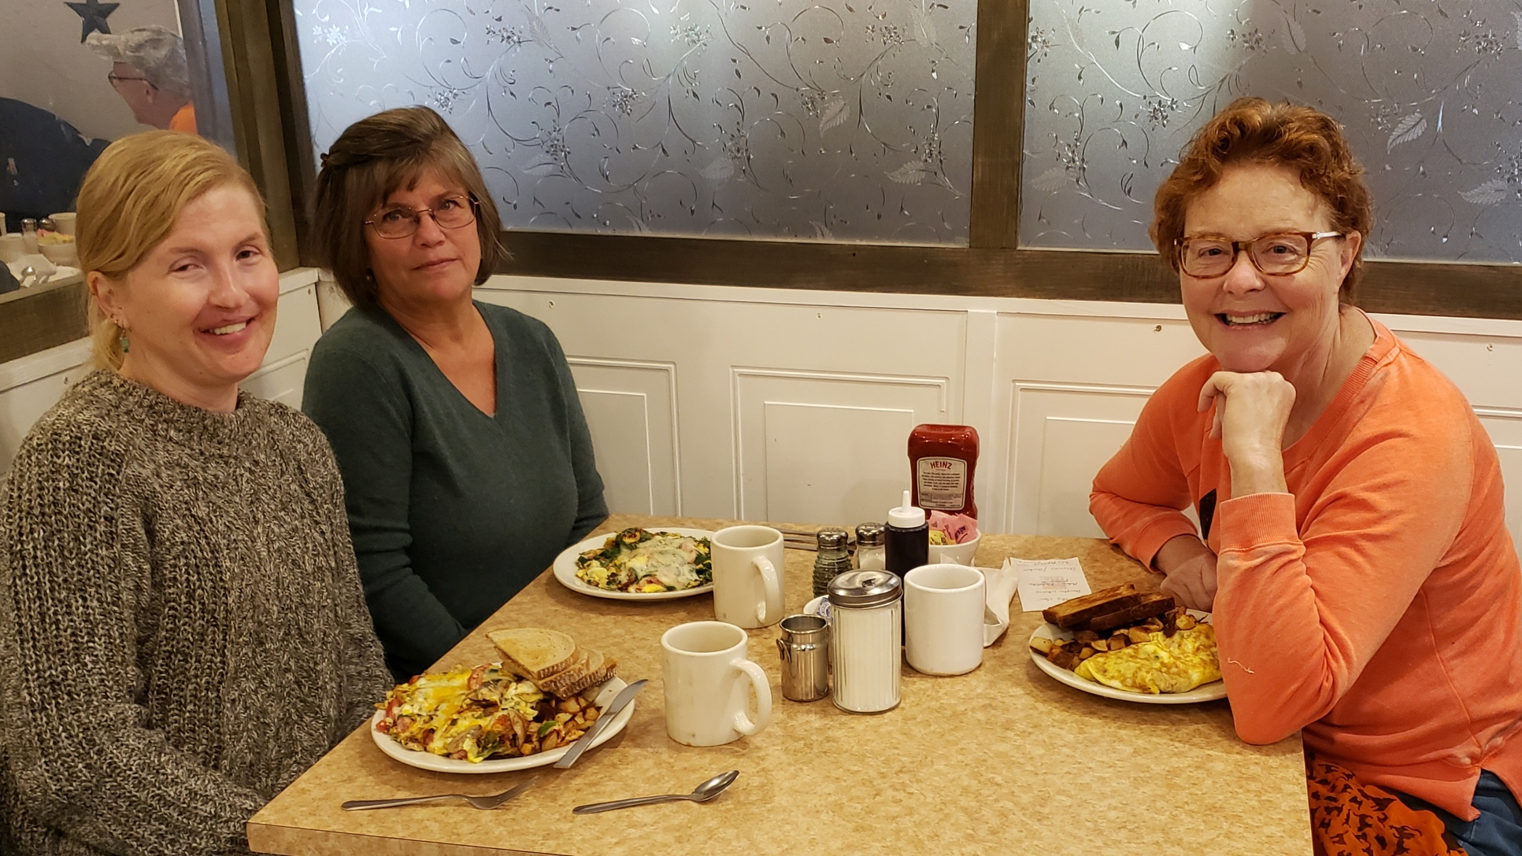
And we (Heather, Melinda & Jennifer) are still here to answer any questions you have and provide advice, just email us: AshfordPollinatorPathways@gmail.com and like our Facebook page: https://www.facebook.com/AshfordPollinatorPathway

.

Ecoregions of New England
By Jennifer Sterling-Folker, December 2022

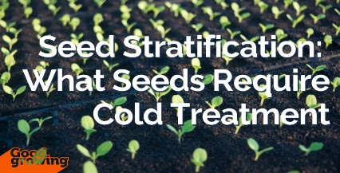
Greetings Ashford! Cold weather is already upon us which means it is time to start thinking about seed stratification. The free native plant seeds we provided through the Babcock Library’s seed bank earlier this year were the “easy growing” kind. If planted at the start of the growing season, they should have germinated and become established over the summer. But many native plant seeds require a period of cold temperatures to break their dormancy cycle which means they need to undergo “seed stratification.” Stratification occurs naturally when seeds are sown outdoors through the cold winter. It is a survival mechanism so the seed does not prematurely germinate.

If you have specific plant seeds that you want to grow for your garden but they need seed stratification, there are various techniques for replicating the stratification process. All involve simulating natural conditions seeds would experience in the soil over-winter, thereby helping to "break dormancy" to begin the spring germination process.

How do you know which native plant seeds need stratification? Common varieties that require it for spring planting are Milkweed (Asclepias), Lupine (Lupinus), Bee Balm (Monarda), Blazing Stars (Liatris), Coneflower (Echinacea), and Ironweed (Vernonia). You can find lists online & most native plant seed packets indicate what kind of propagation method is required. Mail-order native plant seed suppliers also provide information on line to help. Prairie Moon Nursery in Minnesota has germination codes on their seed packets, instructions come with the seeds, and its webpage has a step-by-step guide: https://www.prairiemoon.com/blog/How-to-Germinate-Native-Seeds. Prairie Nursery based in Wisconsin also specifies germination process on its packets and has a webpage on the different techniques utilized: https://www.prairienursery.com/resources-guides/seed-stratification/

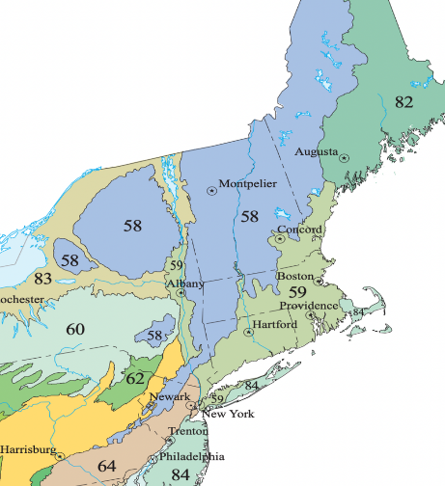
While the above are reliable mail-order nurseries for native plant seeds, native plants thrive best if they are specific to their region. Here in CT we have Eco59 (https://www.eco59.com) which collects and sells native plant seeds for our region (See map to right). There are growing instructions on their website and they offer a seed stratification kit. For native plants specific to the larger New England region, also check out Maine’s Wild Seed Project page on native plant seeds:
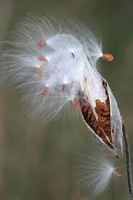
https://wildseedproject.net/how-to-grow-natives-from-seed/

We currently have two kinds of Milkweed (Asclepias) seeds on hand that we collected ourselves– Common (Syriaca) and Swamp Swamp Milkweed. If you’d like some to try your hand at winter stratification, email us at AshfordPollinatorPathways@gmail.com

